Cyber Security Task-7

Objective: Learn to spot and remove potentially harmful browser extensions.

--------------------------------------------------------

1. Opened Browser Extension Manager.

I opened the *Extensions / Add-ons manager* in Microsoft Edge to view all installed extensions.

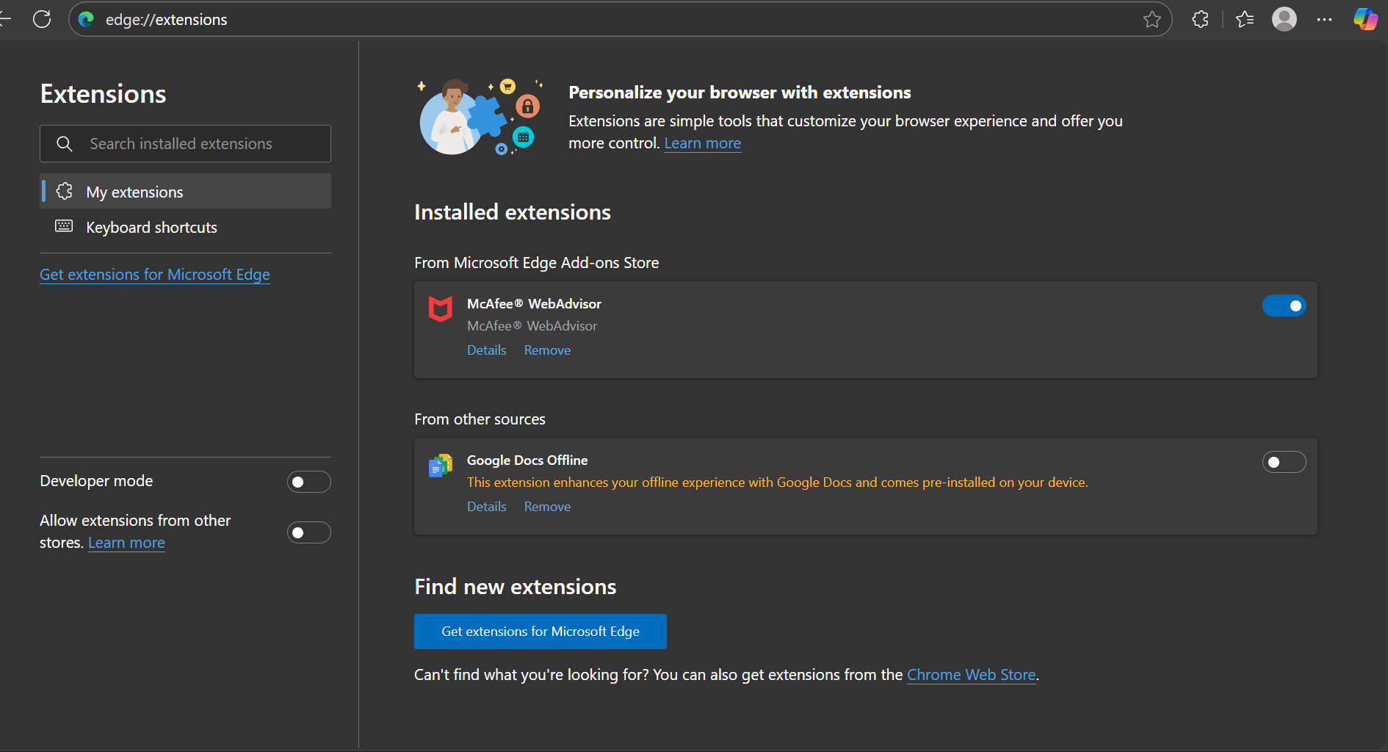

-------------------------------------------------------------------------

1. Reviewed Installed Extensions.

I carefully checked each installed extension. In my case, I found two extensions:

* *McAfee WebAdvisor* (enabled)
* *Google Docs Offline* (disabled)

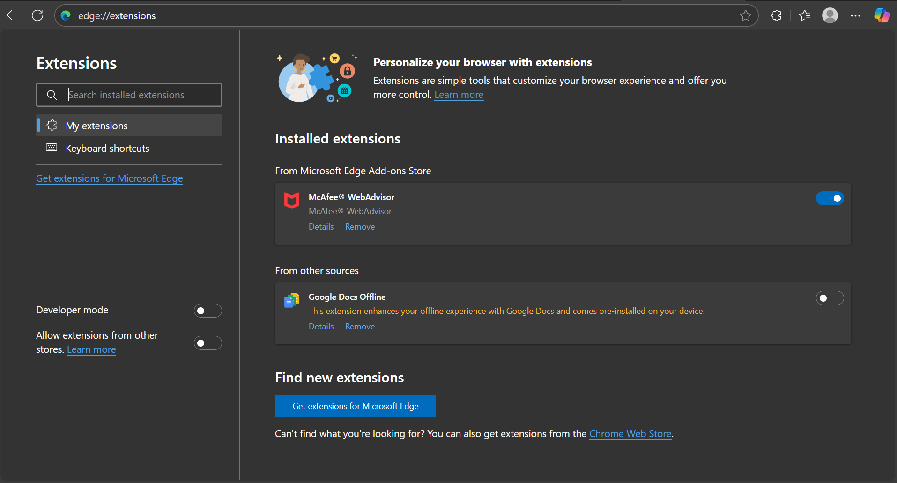

----------------------------------------------------------

1. Checked Permissions and Reviews.

• For McAfee WebAdvisor, I reviewed the permissions (read browsing history, block content, manage downloads, etc.). It is a legitimate extension, but permissions are broad.

• Google Docs Offline was already disabled and is safe, provided by Google.

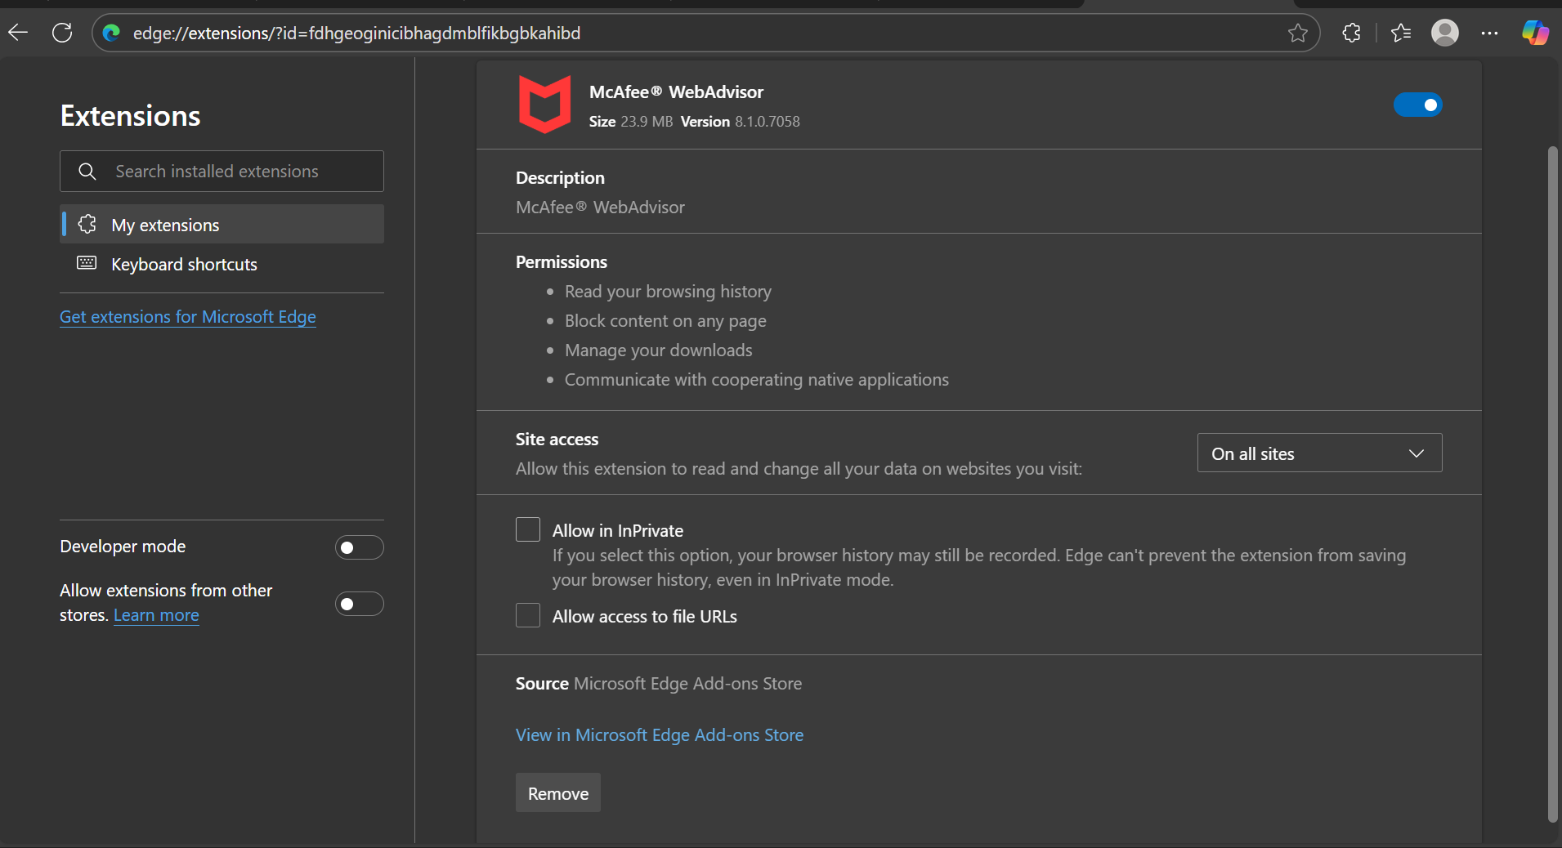

----------------------------------------------------

1. Identified Unused or Suspicious Extensions.

• Google Docs Offline → unused, kept disabled.

• McAfee WebAdvisor → safe but optional, not suspicious.

-------------------------------------------------------------------

1. Removed/Disabled Unnecessary Extensions.

I chose to keep McAfee WebAdvisor enabled and left Google Docs Offline disabled. No harmful extensions found.

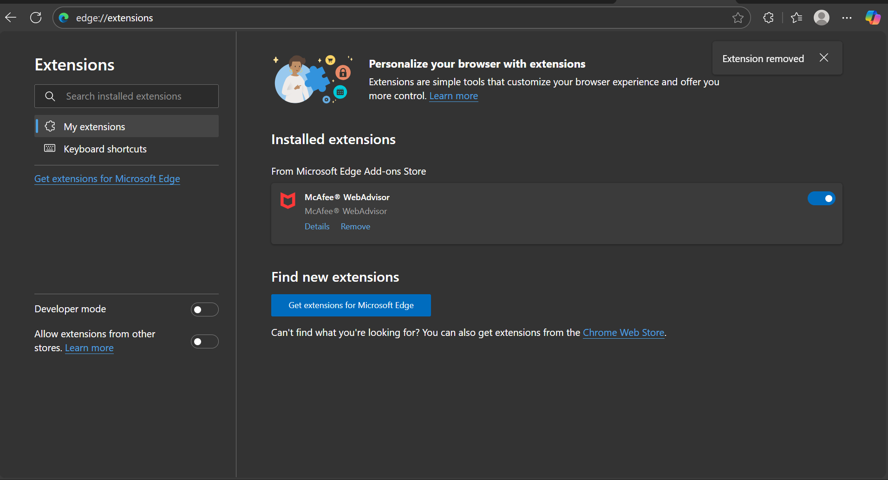

----------------------------------------------------

1. Restarted Browser & Checked Performance.

After restarting Microsoft Edge, browsing performance remained stable. Since only two extensions were present, no major difference was noticed.

----------------------------------------------------------

1. Researched Malicious Extension Risks.

Malicious extensions can:

* Track browsing history and personal data.
* Inject ads, pop-ups, or redirects into sites.
* Steal login credentials or financial information.
* Slow down the browser and overall system.

----------------------------------------------------------

1. Documented Steps & Extensions Reviewed.

Installed extensions: McAfee WebAdvisor (enabled), Google Docs Offline (disabled).

No suspicious extensions found.

Action taken: Confirmed safety, removed none, left one disabled.

Browser runs safely with minimal extensions.

-------------------------------------------------------------------